Pizza Sales SQL Queries

1. KPI’s
2. **Total Revenue:**

SELECT SUM(total_price) AS Total_Revenue FROM pizza_sales;

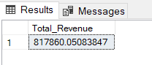

1. **Average Order Value:**

SELECT SUM(total_price)/COUNT(DISTINCT order_id) AS AVG_Order_Value FROM pizza_sales;

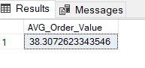

1. **Total Pizza Sold:**

SELECT SUM(quantity) AS Total_Pizza_Sold FROM pizza_sales;

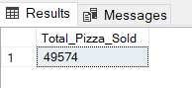

1. **Total Orders:**

SELECT COUNT(DISTINCT order_id) AS Total_Pizza_Order FROM pizza_sales;

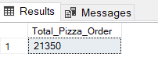

1. **Average Pizza Per Order:**

SELECT CAST(CAST(SUM(quantity) AS DECIMAL(10,2))/

CAST(COUNT(DISTINCT order_id) AS DECIMAL(10,2)) AS DECIMAL(10,2)) AS Avg_Pizza_Per_Order FROM pizza_sales;

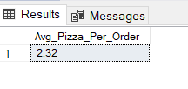

1. **Daily Trend For Total Orders:**

SELECT DATENAME(DW, order_date) AS order_day, COUNT(DISTINCT order_id) as Total_Order

FROM pizza_sales GROUP BY DATENAME(DW, order_date);

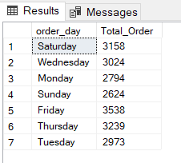

1. **Monthly Trend For Total Orders:**

SELECT DATENAME(MONTH, order_date) AS Month_Name, COUNT(DISTINCT order_id) AS Total_Orders

FROM pizza_sales GROUP BY DATENAME(MONTH, order_date)

ORDER BY Total_Orders DESC;

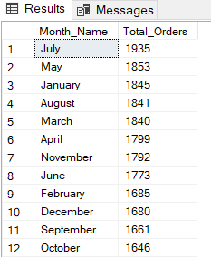

1. **Percentage Of Sales By Pizza Category:**

SELECT pizza_category,SUM(total_price) AS Total_sale,SUM(total_price) * 100 /

(SELECT SUM(total_price) FROM pizza_sales WHERE MONTH(order_date) = 1) AS Percentage_of_TS

FROM pizza_sales

WHERE MONTH(order_date) = 1

GROUP BY pizza_category;

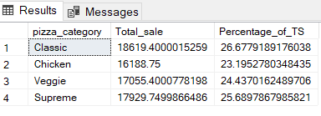

1. **Percentage Of Sales By Pizza Size:**

SELECT pizza_size, CAST(SUM(total_price) AS DECIMAL(10,2)) AS Total_sale, CAST(SUM(total_price)*100/

(SELECT SUM(total_price) FROM pizza_sales WHERE DATEPART(quarter, order_date) = 1) AS DECIMAL(10,2)) AS Percentage_of_TS

FROM pizza_sales

WHERE DATEPART(quarter, order_date) = 1

GROUP BY pizza_size

ORDER BY Percentage_of_TS DESC;

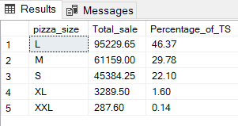

1. **Top 5 Pizzas By Revenue:**

SELECT TOP 5 pizza_name, SUM(total_price) AS Total_Revenue FROM pizza_sales

GROUP BY pizza_name

ORDER BY Total_Revenue DESC;

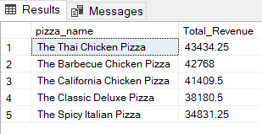

1. **Bottom 5 Pizzas By Revenue:**

SELECT TOP 5 pizza_name, SUM(total_price) AS Total_Revenue FROM pizza_sales

GROUP BY pizza_name

ORDER BY Total_Revenue ASC;

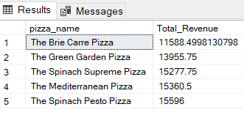

1. **Top 5 Pizzas By Quantity:**

SELECT TOP 5 pizza_name, SUM(quantity) AS Total_Quantity FROM pizza_sales

GROUP BY pizza_name

ORDER by Total_Quantity DESC;

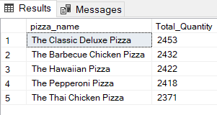

1. **Bottom 5 Pizzas By Quantity:**

SELECT TOP 5 pizza_name, SUM(quantity) AS Total_Quantity FROM pizza_sales

GROUP BY pizza_name

ORDER by Total_Quantity ASC;

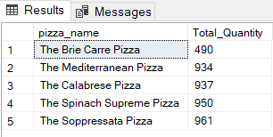

***NOTE***

If you want to apply the Month, Quarter, Week filters to the above queries you can use WHERE clause. Follow some of the below examples

SELECT DATENAME(DW, order_date) AS order_day, COUNT(DISTINCT order_id) as Total_Order

FROM pizza_sales

WHERE MONTH(order_date) = 1

GROUP BY DATENAME(DW, order_date);

**\***Here MONTH(order_date) = 1 indicates that the output is for the MONTH of JANUARY. MONTH(order_date) = 4 indicates output for the MONTH of APRIL.

SELECT DATENAME(DW, order_date) AS order_day, COUNT(DISTINCT order_id) as Total_Order

FROM pizza_sales

WHERE DATEPART(QUARTER, order_date) = 1

GROUP BY DATENAME(DW, order_date);

**\***Here DATEPART(QUARTER, order_date) = 1 indicates that the output is for the Quarter 1. DATEPART(QUARTER, order_date) = 3 indicates output for Quarter 3.